YOLOv5s – Tests on Thermal Imaging Data

Dataset
- 300 images captured with a thermal camera
  - 290 images at 640×512 resolution
  - 10 images at 320×256 resolution
Command used:
python detect.py --weights yolov5s.pt --source thermal_images_chinese/ --project results --name thermal_images_chinese --exist-ok
- 5 videos, each with 300+ frames, resolution 512×640
Command used:
python detect.py --weights yolov5s.pt --source thermal_images/ --project results --name thermal_images --exist-ok

Model
- YOLOv5s pre-trained on COCO dataset
- Detection threshold: conf = 0.25

Results
  - Videos
IR_AIRPLANE_001
- Airplane detected in one frame (confidence ~0.36)
- Remaining detections incorrect
IR_BIRD_013
- No detections
IR_DRONE_026
- No detections
IR_DRONE_082
- No detections
IR_HELICOPTER_011
- No detections, except a background building incorrectly classified as a train
  - Images
- For images with 320×256 resolution → no detections
- Overall detection statistics:
  - 27 airplanes (most of which were actually drones)
  - 11 trains (false positives – background buildings)
- Typical confidence range: 0.28–0.40

Example images results: 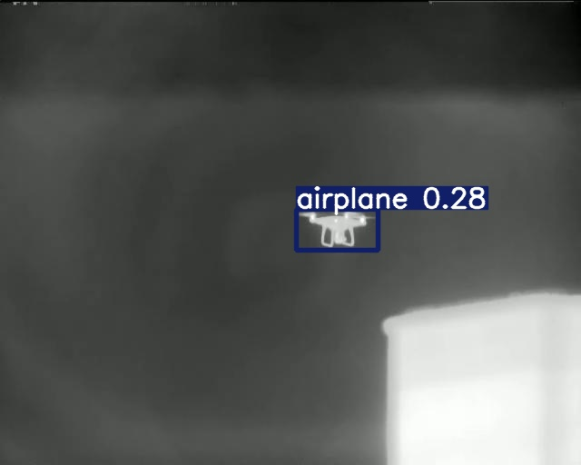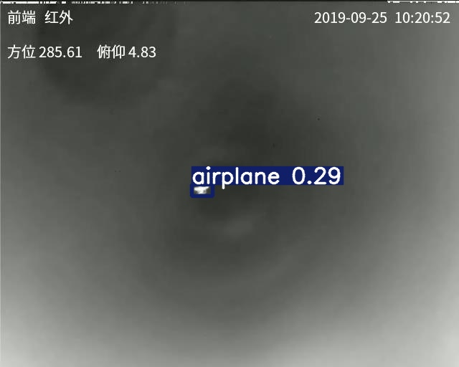
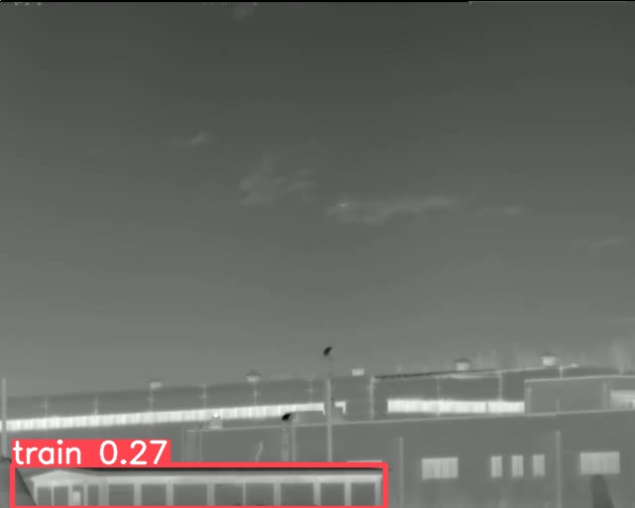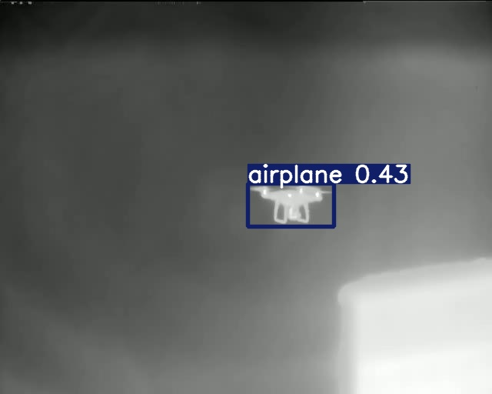

Conclusions
- YOLOv5s, pre-trained on COCO, does not include a “drone” class.
  - Some drones were still detected but mislabeled as airplanes.
- The COCO dataset contains color (RGB) images, while our data is infrared (thermal), which strongly reduces model performance.
- IR images in this task are not well suited for an out-of-the-box COCO-trained model.
- YOLOv5s is optimized for a 640×640 input size, which is the default and recommended resolution in the official Ultralytics configuration. Using lower or non-square resolutions (such as 512×640 or 320×256) further decreases detection accuracy, especially for small objects.

Next steps:
Fine-tune or retrain the model using a labeled ground-truth thermal dataset, and then re-evaluate performance.

